CMR Institute of Technology
Kandlakoya Village, Medchal Rd, Hyderabad, Telangana 501401
Institute Innovation cell
Developing Online Repository of Ideas Developed and Wayforward plan

Team Name : BIA (Brothers in arms)
Members:
1. 21R05A0411 ( BIYYALA VASUDEV )
2. 21R05A0412 ( KOLCHALMA SHEKAR )
Idea Title: Blind Guide
Problem Statement:
To detect obstacles on the road by blind person and to avoid them using alerts from then device

OVERVIEW
We are going to built a smart stick for blind people in this we are going to use uv sensor and flame sensor in this we are going to add a fire fighter so that he can survive in flames by use of fire fighter inbult in stick

GOALS/Objectives
- He can easly survive in fire accidents for 15 minutes
- He can use for free walking
SPECIFICATIONS
1. SIMPLE TO USE
2. BATTERY CHANGEABLE
3. LESS WEIGHT
4. LESS COST
5. FIRE FIGHTER
6. SIMPLE TO CARRY

MILESTONES

Ideation/Data collection
I went to a park to watch surroundings I saw a blind is trying to walk on the track so I tried to communicate to him he told his total story I went to my brother’s,friend’s and family members and discussed with them and they gave some ideas like do a poject using sensors and etc things for blind people
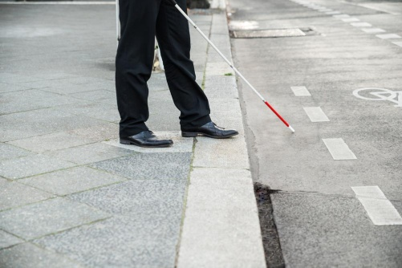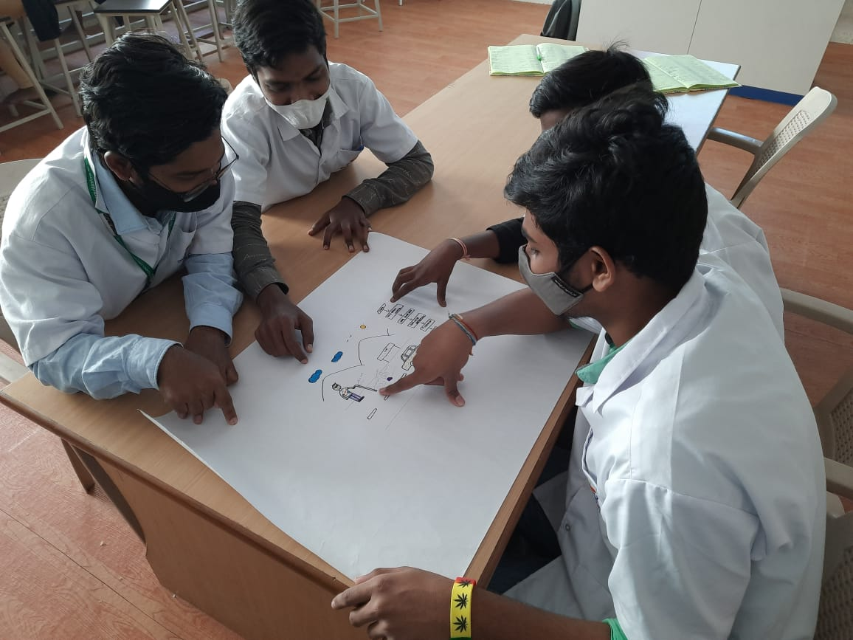

Fig 1: Problem scenario

Model Building
We are using ardiuno to connect to uv sensor and flame sensor on the stick and buzze for alerting user and also with vibrator for more alerting.

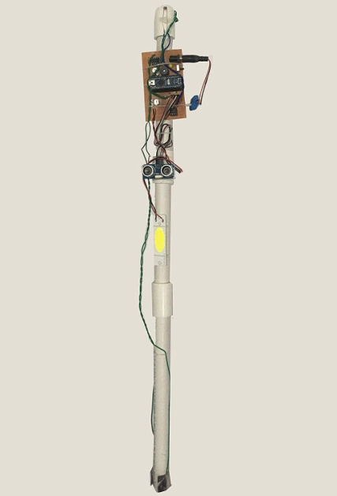
Fig 2 Model or blueprint

Components/Tools Understanding and usage
We are going to use arduino, uv sensor, flame sensor ,gas or water ,battery ,jumper wires and arduino ide software

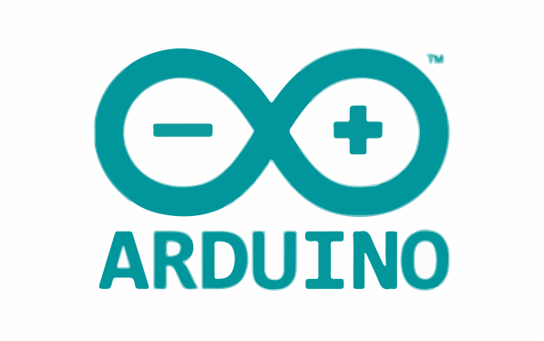
Fig 3.1: Arduino software
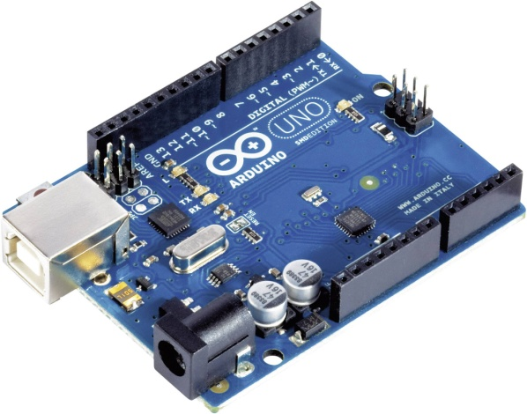
Fig 3.2 : Arduino uno
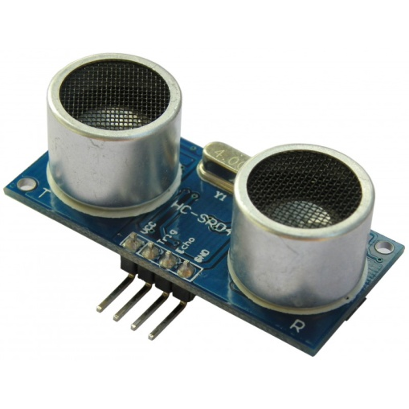
Fig 3.3: uv sensor
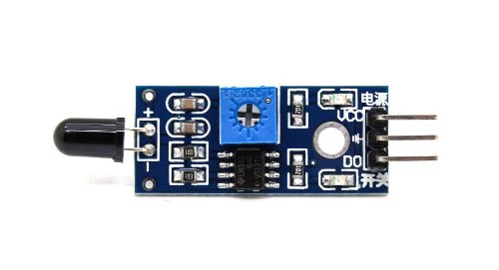
Fig 3.4: flame sensor
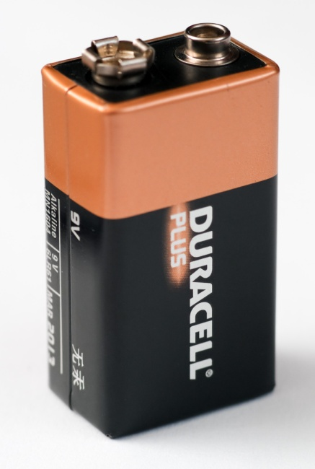
Fig 3.5: Battery
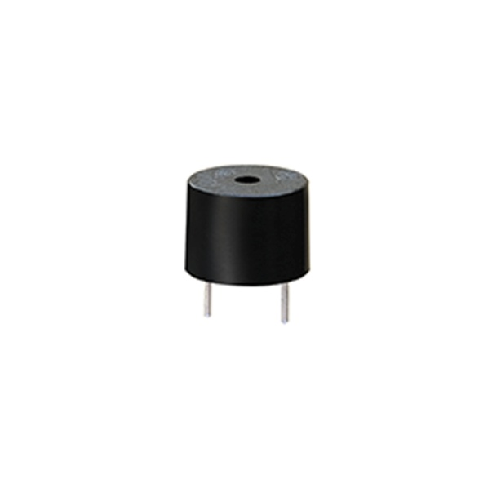
Fig 3.6: Dc buzzer
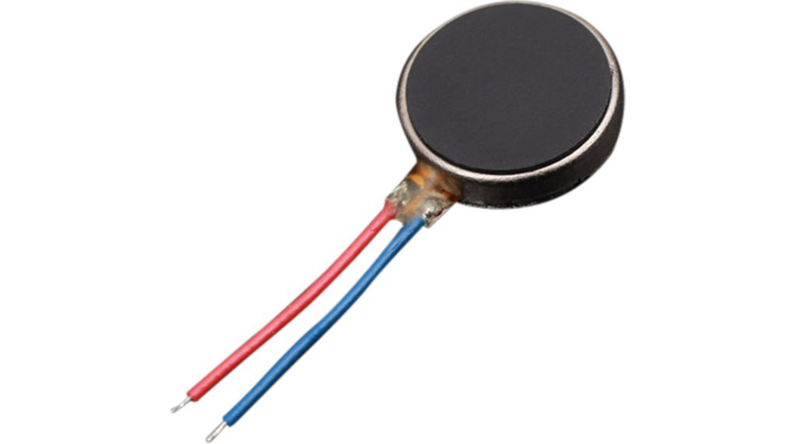
Fig 3.7: vibrator

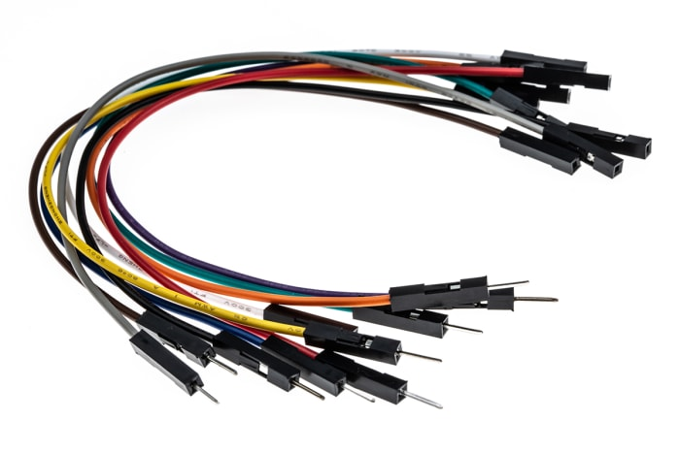
Fig 3.8: jumper wires

